34.76: a) The image from the left end acts as the object for the right end of the rod.
b) 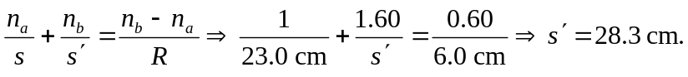
So the second object distance is 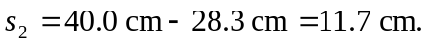
Also: 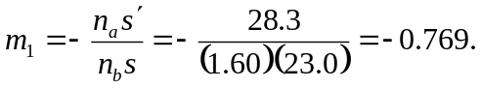
c) The object is real and inverted.
d) 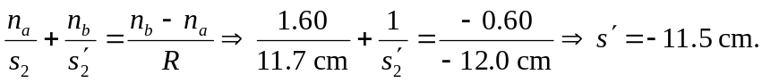
Also:
e) So the final image is virtual, and inverted.
f)

